Piling Noise Mitigation and Bubble Curtain Plan
Harrow Bay Offshore Wind
Hannah Weber · 20 March 2026 · HB-HSE-PLN-0012

1. Purpose
This plan describes how underwater noise from percussive piling at Harrow Bay is reduced and monitored so that the consent conditions are met. It implements condition 16 (noise limit) and condition 14 (seasonal piling restriction) of the development consent and the marine licence, and the Marine Mammal Mitigation Protocol agreed with the regulator.

2. Consent requirements
Condition | Requirement
14 | No percussive piling between 1 July and 31 July
15 | Soft start of at least 20 minutes; 30-minute pre-piling search (MMO and PAM)
16 | Single-strike sound exposure level (SEL) ≤ 160 dB re 1 µPa²s at 750 m from the pile
17 | Monthly noise monitoring report to the regulator; exceedances reported within 24 hours
18 | No concurrent piling with neighbouring projects within 26 km without approval

3. Double big bubble curtain (DBBC)
Two perforated hose rings are laid on the seabed around the pile at radii of approx. 70 m and 95 m. Compressors on the support vessel deliver 0.5 m³/(min·m) of free air, creating a curtain of rising bubbles that attenuates the noise by 12–17 dB (broadband). The hoses are deployed by the support vessel before MV Sea Atlas starts the soft start.
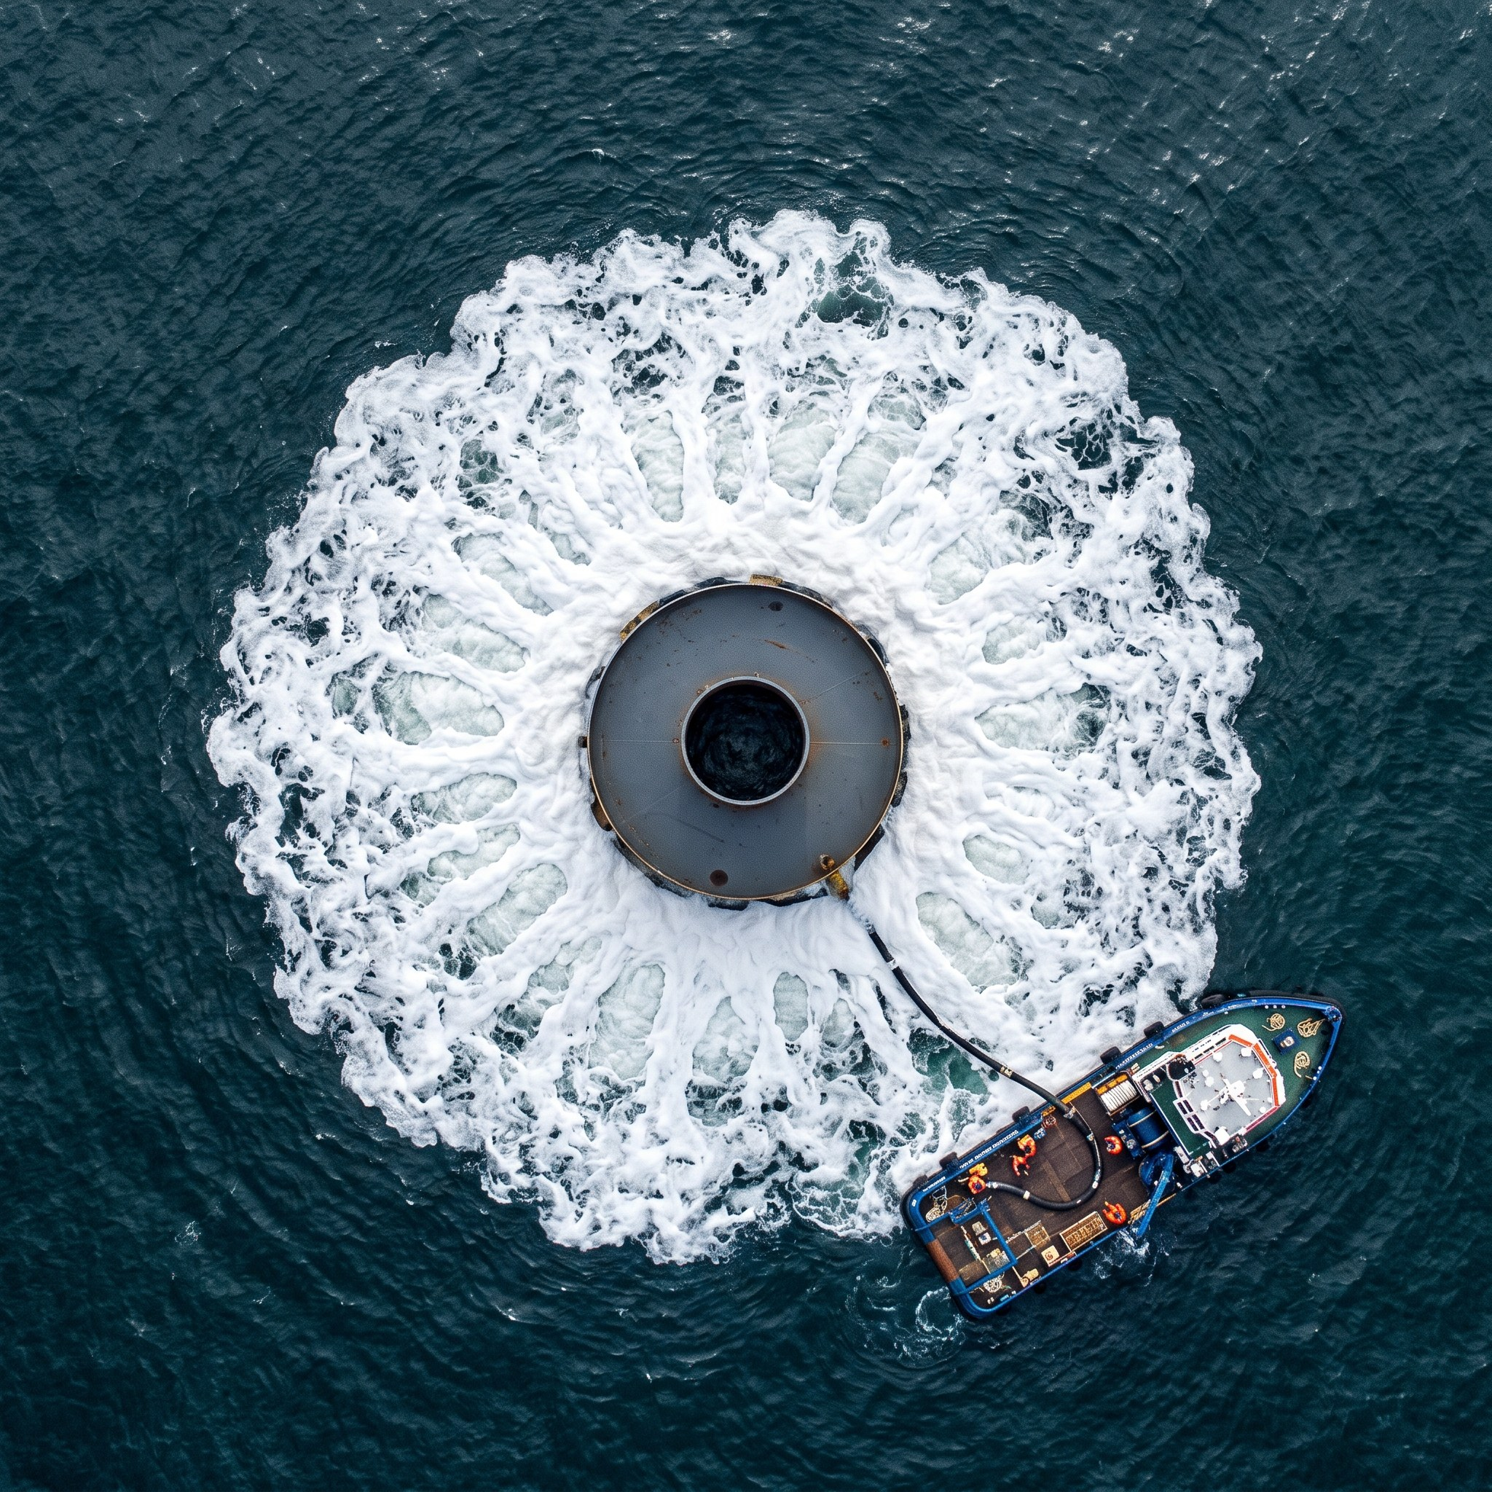
Double big bubble curtain at HB-A06, 12 May 2026
Parameter | Value
Hose rings | 2 (inner 70 m, outer 95 m radius)
Air volume | ≥ 0.5 m³/(min·m), 8 compressors
Nozzle spacing | 0.3 m, 1.5 mm holes
Deployment weather limit | Hs 1.8 m, wind 12 m/s
Expected attenuation | 12–17 dB SEL

4. Additional measures
- Hammer energy limited to 3,000 kJ (decision D-008)
- Acoustic deterrent device (ADD) activated 30 minutes before soft start
- Marine Mammal Observer (MMO) and passive acoustic monitoring (PAM) by Marlow Ecology
- Piling start delayed if a marine mammal is detected within the 750 m mitigation zone

